Phonics at Home with the Family during School Closure

It can be very difficult to effectively home school our children, without the technology or resources to feel that we as parents or carers are doing a fantastic job. However, please let me assure you, that everyone is feeling the same way. Therefore, I have come up with some simple phonic resources and ideas that you and your child can do together, or your child can do on their own, when you are busy with their siblings or working from home yourself.

Flash Cards
If you do not have the RWI flash cards, this is not a problem. You could make them! They could write the sound on one side of the card or paper, draw the picture, and rhyme on the reverse. This will keep them busy for hours and they will enjoy them so much, as they will feel so proud of their achievements! You could do your own mini speed sound session every day and over a period of time you will be surprised by the results you get from just a simple 5-minute session.

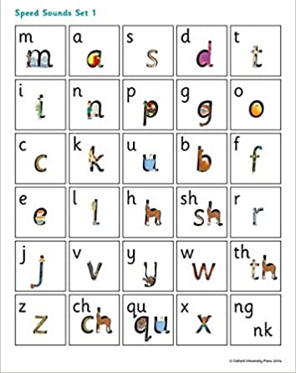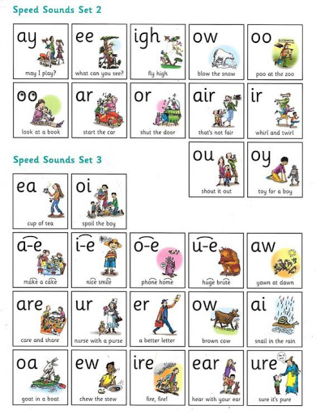

Please see the following websites for support:

- Watch Read Write Inc. phonic Speed Sound lessons at home. Lessons show at 10.00 am, from Monday to Friday. Each one is ten minutes long and available for 24 hours. After Easter, RWI will be adding further session to help with spelling. https://www.youtube.com/channel/UCo7fbLgY2oA_cFCIg9GdxtQ

- Oxford Owl provides a useful guide on how to pronounce sounds and blend sounds together to read words. https://home.oxfordowl.co.uk/reading/learn-to-read-phonics/
Phonic Fun Games
Phonics Play: A site packed with interactive phonics games. To access all their phonic resources and fun games, all you need to do is log on using the following details: Username: march20 Password: home
https://new.phonicsplay.co.uk/

Sound Hunt Games
Now you have your cards, you could use them for games, such as a sound hunt. Randomly choose a card that you know your child recognises, and sent them off around the house, flat or garden to see how many objects or things that they can spot with the sound in it, recording what they find on some paper. Reading and writing all at once! You could make it a race with a sibling!

Corners Games
Put up four of the cards around the room or garden, call out a word that contains one of the sounds, and they have to make a dash for that card! A good active game to tire them out!

I Spy
You could play I Spy games. Make them more challenging for the older children, by using the sounds in a word “I spy with my little eye, something with the sound er”. Flower! Then see if they can write the word. For our younger children see if they can play I Spy with the initial sounds and ask them to have a go at writing the word or initial sounds.

Phonics does not have be done online! Here are some more ideas for you to try to make at home…

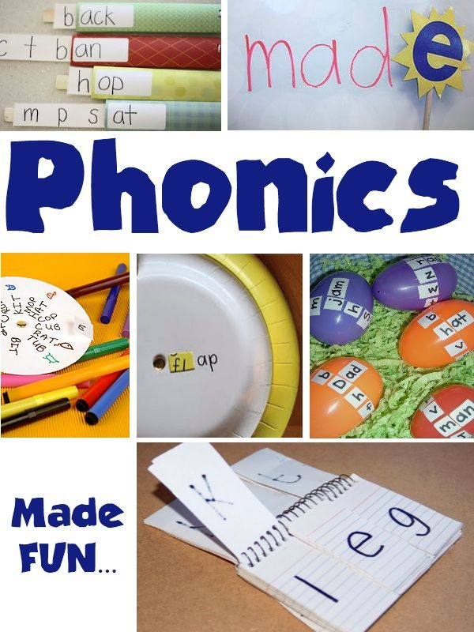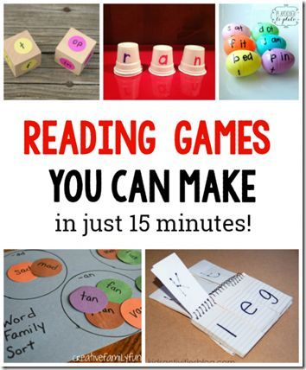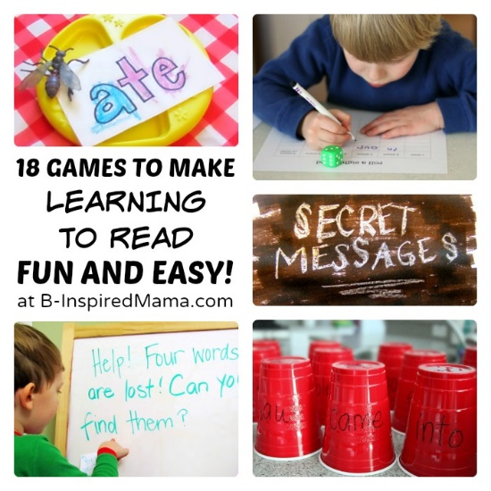

Most importantly though, is that you are all well and you are not finding phonics too overwhelming. You will make mistakes, as will your children, but that’s ok, that’s how we learn! Remember the 6 R’s and the fruits of the spirit, and you will get through this… this isn’t forever. We will see you all very soon.
Best regards

Mrs R Boyle
Phonics Lead

